
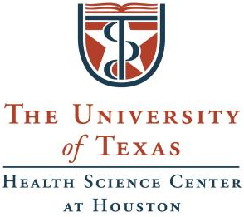


Training in Precision Environmental Health Sciences (TPEHS)

Program Director:
Cheryl Walker, PhD, Director, Center for Precision Environmental Health, Professor, Molecular & Cell Biology, and Medicine, Baylor College of Medicine

Program Co-Directors:
Swathi Arur, PhD, Professor, Genetics, MD Anderson Cancer Center;
Daniel Gorelick, PhD, Associate Professor, Cellular & Molecular Biology, Baylor College of Medicine, and
Elmer Bernstam, MD, MSE, Professor, Clinical and Health Informatics, Internal Medicine, UTHealth Houston, UT Health Science Center at Houston.

http://www.gulfcoastconsortia.org/home/training/training-in-precision-environmental-health-sciences-tpehs/

Meet the TPEHS Trainees

The following trainees are supported by T32ES027801, a NIEHS T32 program:


Joshua Lindenberger
Appointed: June 1, 2026 – May 31, 2027 (Grant year 07)
Department of Genetics and Epigenetics, MD Anderson Cancer Center
Primary Mentor: Dr. Guillermina (Gigi) Lozano, Genetics, MDA
Secondary Mentors: Dr. Han Xu, Epigenetics and Molecular Carcinogenesis, MDA; Dr. Bin Wang, Genetics, MDA
Characterization of Metastatic Cellular Dormant Tumor Cells and Microenvironment from Mutant Trp53 Driven Breast Cancer
My project leverages a mutant p53 driven murine breast cancer to study metastatic cellular dormancy. By studying the transcriptome in the context of spatial localization, we can begin to understand this rare cell population. Beyond this, clinical data show patient obesity impacts tumor recurrence, and we will model this in mice to observe impacts on dormancy.


Noah Powell
Appointed: February 1, 2025 – January 31, 2027 (Grant year 06, 07)
Program in Cancer and Cell Biology, Baylor College of Medicine
Primary Mentor: Dr. Jason Lee, Molecular and Cellular Biology, BCM
Secondary Mentors: Dr. Swathi Arur, Genetics, MDA; Dr. Ronald Parchem, Molecular and Cellular Biology, BCM
The Functional Tunability of Membrane-less Organelles in Response to Environmental Stressors
In response to environmental stresses, such as heat or arsenic exposure, cells employ an acute compartmentalization mechanism that changes how mRNAs are organized and utilized within minutes of exposure. This acute compartmentalization of mRNAs is governed by the striking formation of membrane-less organelles, such as mRNA processing(P)-bodies. Extensive research into membrane-less organelles has been conducted over the last decade to uncover their dynamics and composition; however, many of their functions are still unclear. Therefore, the overarching goal of my research is to develop novel assays to uncover the function of membrane-less organelles, specifically when cells are exposed to different environmental stresses.


Usosa Too-Chiobi
Appointed: June 1, 2026 – May 31, 2027 (Grant year 07)
Program in Development, Disease Models, and Therapeutics, Baylor College of Medicine
Primary Mentor: Dr. Daniel Gorelick, Molecular and Cellular Biology, BCM
Secondary Mentor: Dr. Cristian Coarfa, Molecular and Cellular Biology, BCM
The Role of ARNT2 Protein as a Repressor of Aryl Hydrocarbon Receptor-Mediated Transcription
Environmental pollutants such as dioxins and PCBs activate the aryl hydrocarbon receptor (AHR), a transcription factor that regulates genes involved in detoxification. While AHR's required partnership with ARNT1 is well established, the role of a related protein, ARNT2, in modulating AHR activity in human cells remains unknown. Using zebrafish, our lab found that ARNT2 represses AHR target gene expression, but whether this occurs in human cells has not been tested. To address this, I will use gain- and loss-of-function experiments across multiple human cell lines, combined with RNA sequencing to determine whether ARNT2 represses AHR-ARNT1-mediated gene expression. Because AHR ligands are widespread environmental health concerns, understanding how ARNT2 shapes AHR signaling is critical for assessing the human health consequences of pollutant exposure.


Xing Zhang
Appointed: February 1, 2025 – January 31, 2027 (Grant year 06, 07)
Program in Genetics and Epigenetics, MD Anderson Cancer Center
Primary Mentor: Dr. Georgios Karras, Genetics, MDA
Secondary Mentor: Dr. Chad Huff, Epidemiology, MDA
Interrogating Environmental Determinants of HSP90-Buffered Phenotypes
Predicting the clinical pathogenicity of germline mutations is challenging due to gene-environment interactions that contribute to the incomplete penetrance and variable expressivity of phenotypes. The protein-folding chaperone HSP90 may account for much of this phenotypic variation, as it can suppress or “buffer” the deleterious effects of mutations at the cost of rendering phenotypic expression conditional on proteotoxic stressors in the environment. Using the genome instability-associated DNA repair genes FANCA and BRCA1 as models, my project aims to identify common proteotoxic stressors found in the environment that can reveal HSP90-buffered phenotypes. Moreover, it will determine the impact of HSP90-mediated gene-environment interactions on clinical phenotypes, such as cancer, in the general population.

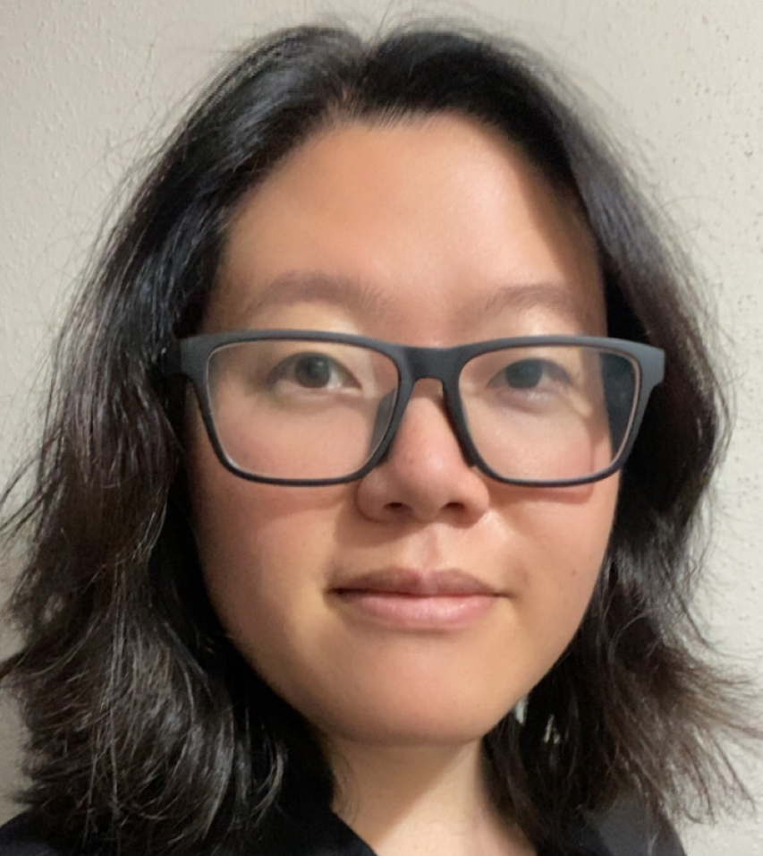
Han Bit Baek, PhD
Appointed: June 1, 2025 – May 31, 2027 (Grant year 06, 07)
Department of Genetics, MD Anderson Cancer Center
Primary Mentor: Dr. Swathi Arur, Genetics, MDA
Secondary Mentor: Dr. Daniel Gorelick, CPEH, BCM
The Role of Flavonoids in Regulating Oocyte Development in C. elegans
Maternal nutrition is a critical factor that influences the quality of her eggs and the health of her offspring. In humans, eggs develop in utero within the fetal gonad. Therefore, starvation and/or dietary exposure to environmental toxins can adversely affect the health of not only her child, but of her grandchildren. To investigate how maternal nutrition regulates egg development, I use C. elegans to assess how flavonoids, a class of bioactive compounds found in fruits and vegetables, affect chromosomal dynamics during oogenesis. Given the importance of proper chromosome segregation during egg formation and the potential for flavonoids to affect this process, my work will uncover how flavonoids affect egg development, which will deepen our understanding of how maternal nutrition influences egg quality.
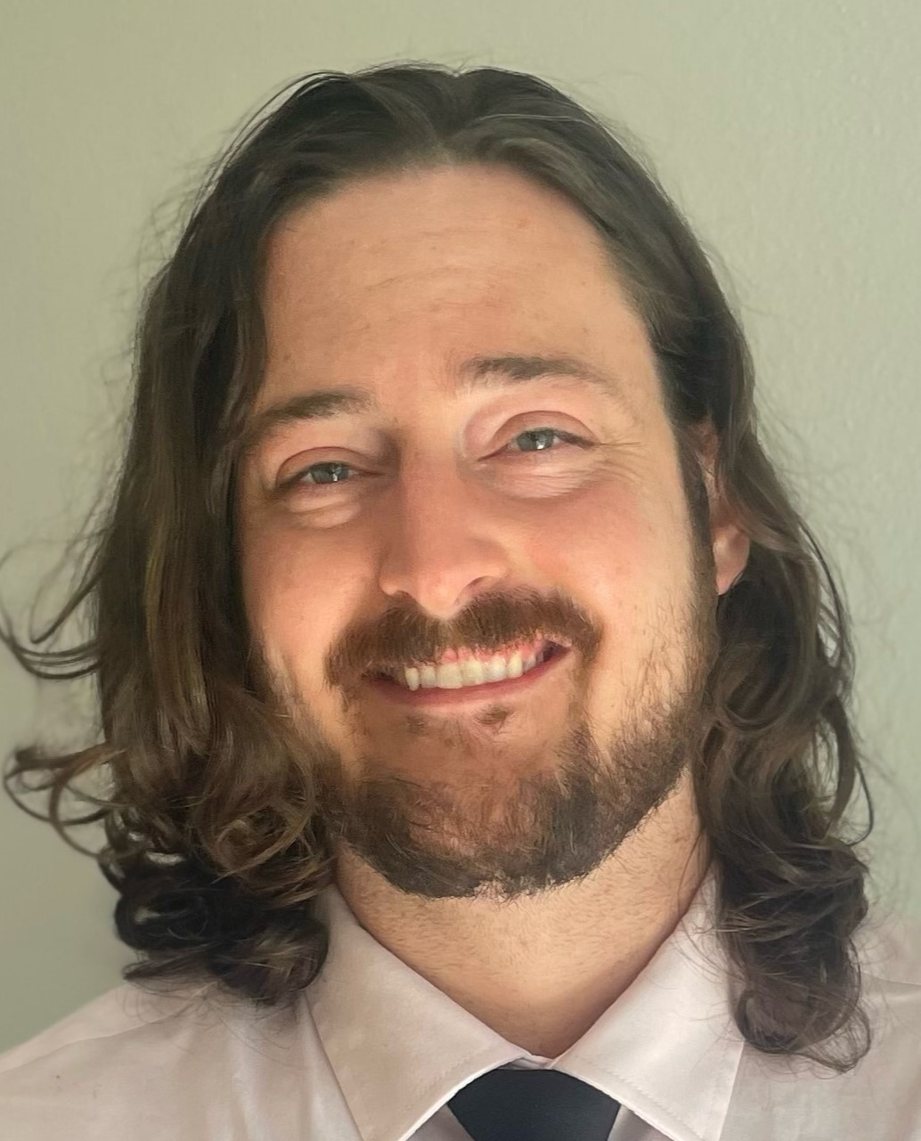
Nicholas Egan, PhD
Appointed: June 1, 2026 – May 31, 2027 (Grant year 07)
Department of Molecular and Cellular Biology, Baylor College of Medicine
Primary Mentor: Dr. Jeanine Van Nostrand, Molecular and Cellular Biology, BCM
Secondary Mentors: Dr. Zheng Sun and Dr. Cristian Coarfa, both Molecular and Cellular Biology, BCM
Diet-Dependent Control of Liver Immune Remodeling by AMPK During MASLD Progression
Metabolic associated steatotic liver disease (MASLD) is a common liver condition linked to obesity, poor diet, and low physical activity, where fat builds up in the liver over time. While many people are exposed to similar chronic dietary environmental stress factors, only some people develop serious liver damage, including inflammation and scarring, and it is not well understood why these differences occur. A key part of disease progression involves changes in the liver’s immune system, which can become overactive or dysfunctional under long term metabolic stress. This project focuses on a protein called AMP activated protein kinase (AMPK), which helps cells respond to energy and dietary changes. Preliminary data suggests that AMPK plays an important role in shaping how immune cells behave in the liver, and that its effects are diet dependent. In this study, I will investigate the impact of AMPK on immune responses during liver disease progression, and how these responses differ under healthy versus high fat dietary conditions. I will use a combination of animal models and advanced molecular tools to examine how liver cells and immune cells interact at each stage of disease progression. By identifying how metabolic factors influence the immune system during chronic dietary environmental stress we can help explain why people respond differently to similar environmental exposures and elucidate more personalized strategies to prevent and treat liver disease.

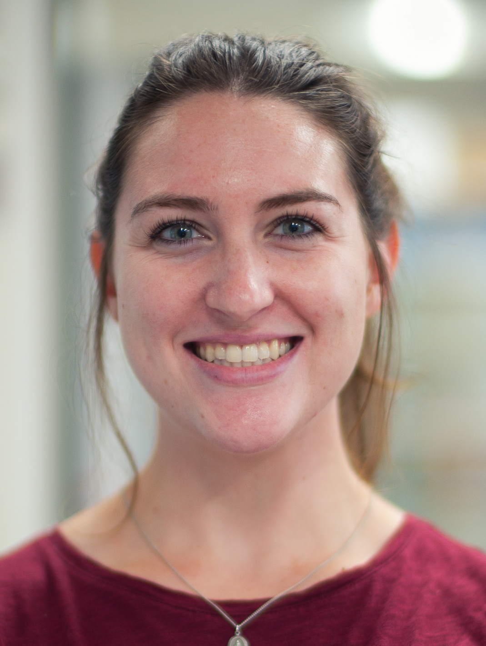
Staci Hammer, PhD
Appointed: July 1, 2026 – June 30, 2027 (Grant year 08)
Department of Biochemistry and Molecular Pharmacology, Baylor College of Medicine
Primary Mentor: Dr. Furqan Fazal, Biochemistry and Molecular Pharmacology, BCM
Secondary Mentor: Dr. Rachel Arey, Molecular and Cellular Biology, BCM
The Role of Pesticide Exposure in Modulating RNA Localization and Translation at the Outer Mitochondrial Membrane (OMM)
Chronic exposure to environmental pollutants can disrupt mitochondrial function and contribute to the development of neurodegenerative disorders, cancers, and other diseases. Almost all (~99%) of the proteins required for mitochondrial function are encoded by the nuclear genome and translated from nuclear-encoded mRNAs, many of which localize to the mitochondrial surface, where they are translated before import into mitochondria. My research will use an RNA proximity labeling approach to profile translating RNAs at the mitochondrial surface in disease states driven by environmental exposures. I will then assess how exposure-induced remodeling of this local RNA landscape impacts mitochondrial function using complementary functional assays. This work will identify genes and mechanisms that locally regulate mitochondrial function in disease conditions and may serve as therapeutic targets.

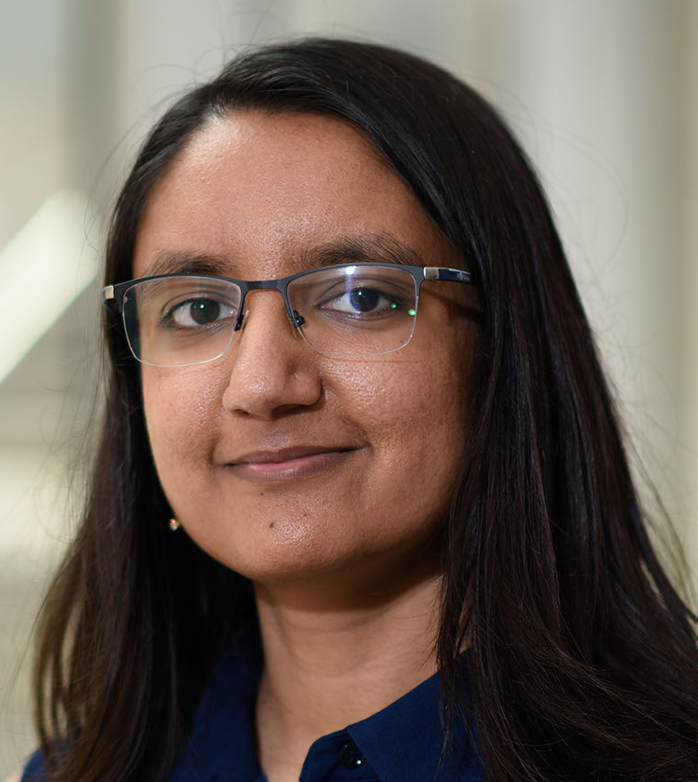
Khushali Patel, PhD
Appointed: June 1, 2025 – May 31, 2027 (Grant year 06, 07)
Department of Molecular and Human Genetics, Baylor College of Medicine
Primary Mentor: Dr. Chonghui Cheng, Genetics, BCM
Secondary Mentor: Dr. H. Courtney Hodges, CPEH, BCM
The Role of Environmental Pollutants in Epigenetic Regulation of Transposons and Cancer Development
Environmental stressors such as arsenic and bisphenol A can disrupt gene regulation – not only by causing DNA mutations but also by acting as molecular switches that turn genes on or off. My research focuses on their effects on a relatively obscure part of the genome called transposons. These repetitive DNA elements are typically silenced, but we have discovered novel transposon-derived RNA transcripts that are differentially expressed during epithelial-mesenchymal transition, a crucial process in development and cancer. In this project, I will investigate the global impact of arsenic and BPA exposure on transposon activity and explore how transposon-derived transcripts alter normal cellular processes to increase risk for diseases such as cancer. This research will reveal the molecular mechanisms linking environmental pollutants to transposon expression and disease.

The following TPEHS trainees receive financial support from their home institutions:

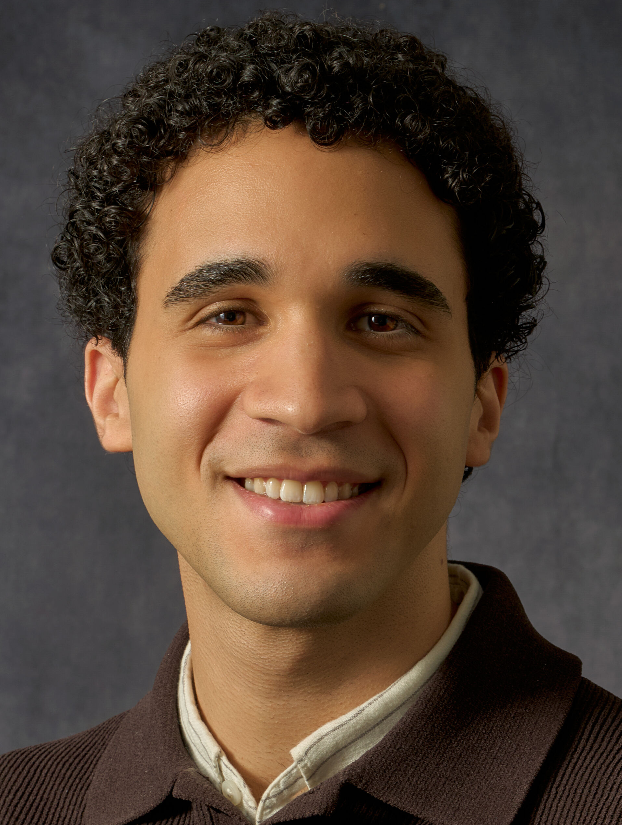
Ahmed Shatta
Appointed: June 1, 2026 – May 31, 2027
Program in Genetics, MD Anderson Cancer Center
Primary Mentor: Dr. Guillermina (Gigi) Lozano, Genetics, MDA
Secondary Mentor: Dr. Swathi Arur, Genetics, MDA
Dietary Polyunsaturated Fatty Acid Exposure as a Modifiable Environmental Determinant of Ferroptosis Sensitivity in Mutant-p53 Driven Breast Cancer
Most triple-negative breast cancers carry mutations in TP53 that protect cancer cells from ferroptosis, a type of cell death that occurs when fats in cell membranes become damaged by oxidation. The fats most prone to this damage, polyunsaturated fatty acids (PUFAs), come from dietary sources like fatty fish, flaxseed, and walnuts, making membrane fat composition a modifiable environmental factor in tumor vulnerability. The goal of my project is to determine whether dietary PUFA enrichment can overwhelm cancer cells' protective defenses and trigger ferroptosis, with the long-term goal of developing nutritional guidance that, paired with existing therapies, may improve outcomes for breast cancer patients.


Udhaya Kumar Siva Kumar, PhD
Appointed: February 1, 2025 – January 31, 2027
Department of Medicine, Baylor College of Medicine
Primary Mentor: Dr. Zheng Sun, Medicine, BCM
Secondary Mentor: Dr. Cristian Coarfa, CPEH, BCM
Intergenerational Effects of Paternal Arsenic Exposure
Extensive air, water, and soil pollution has resulted from urbanization and industrialization. While some progress has been made in reducing pollution, its long-term effects on future generations and their risk for chronic diseases remain unclear. Our study focuses on inorganic arsenic (iAs), a common environmental pollutant in drinking water, to investigate how it impacts health across generations. Male mice exposed to iAs had female offspring with impaired blood sugar regulation and disrupted hypothalamic-pituitary-gonadal (HPG) axis, while male offspring showed lower liver lipid content and triglyceride levels. We found that iAs exposure altered DNA methylation and non-coding RNAs in sperm, which regulate genes linked to hormones and lipid metabolism. We hypothesize that iAs-induced DNA methylation and gene expression changes in the HPG axis can explain the metabolic phenotype in the female offspring. I will use whole genome bisulfite sequencing to analyze DNA methylation in the pituitary. I will use CRISPR-guided epigenome editing to manipulate DNA methylation at specific loci with differential methylation levels in the pituitary. We also will profile RNA modifications in the paternal sperm and early embryos and address their function in epigenetic and phenotypic changes in the offspring. Our study will improve our understanding of how environmental pollutants contribute to chronic diseases like diabetes and fatty liver, helping address the global rise in metabolic disorders.


The TPEHS program is Administered by the:
The GCC is a collaboration of:
Rice University
Baylor College of Medicine
University of Houston
University of Texas Health Science Center at Houston
University of Texas Medical Branch at Galveston
University of Texas MD Anderson Cancer Center
Institute of Biosciences & Technology at Texas A&M Health Science Center
Houston Methodist Research Institute

www.gulfcoastconsortia.org

