




Immunology Training Program (ITP)
Funded by the National Institute of Allergy and Infectious Diseases (NIAID), T32 AI186973

Program Director: David Corry, MD, Professor, Medicine-Immunology, Allergy and Rheumatology, Baylor College of Medicine

Program Co-Director: Roza Nurieva, PhD, Professor, Immunology, The University of Texas MD Anderson
Cancer Center

ITP Website

Meet the Trainees
2026-2027
Christopher Acosta, Cancer and Cell Biology, Baylor College of Medicine

Appointment: October 1, 2026 – September 30, 2027
Mentor: William Decker, PhD, Immunology and Pathology, Baylor College of Medicine
Co-Mentor: Vanaja Konduri, PhD, Immunology and Pathology, Baylor College of Medicine

Project Title: Sensory Neuro-Myeloid Regulation of Immunosuppression and Therapeutic Response in Oral Squamous Cell Carcinoma

Oral squamous cell carcinoma (OSCC) is a common form of head and neck cancer that can grow along nerves, a process called perineural invasion. This pattern of growth is associated with cancer recurrence and worse patient outcomes, but we still do not fully understand how nerves influence the immune system inside these tumors.

My project focuses on the interaction between sensory nerves and myeloid-derived suppressor cells (MDSCs), immune cells that help tumors avoid attack by T cells. Sensory nerves are especially abundant in the tongue, where many oral cancers arise. Recent studies suggest that nerves can release signals that change immune-cell behavior, but whether sensory nerves directly support MDSCs in oral cancer remains unclear.

Our laboratory developed a multi-agent treatment, which I refer to as multi-pathway immunologic effector (MPIE) therapy, that strongly reduces MDSCs and can eliminate aggressive tumors in mice. Unexpectedly, previous studies also showed major changes in nerve-related cells after treatment. I will therefore use an oral tongue tumor model to determine whether MPIE changes sensory nerves and MDSCs together, whether suppressive MDSCs preferentially gather near nerves, and whether sensory signals directly affect MDSC function.

Finally, I will selectively remove sensory neurons in mice to test whether these nerves are required for tumor immune suppression or for the response to MPIE therapy. These studies may identify simpler nerve–immune pathways that could eventually be targeted to improve treatment of oral cancer.

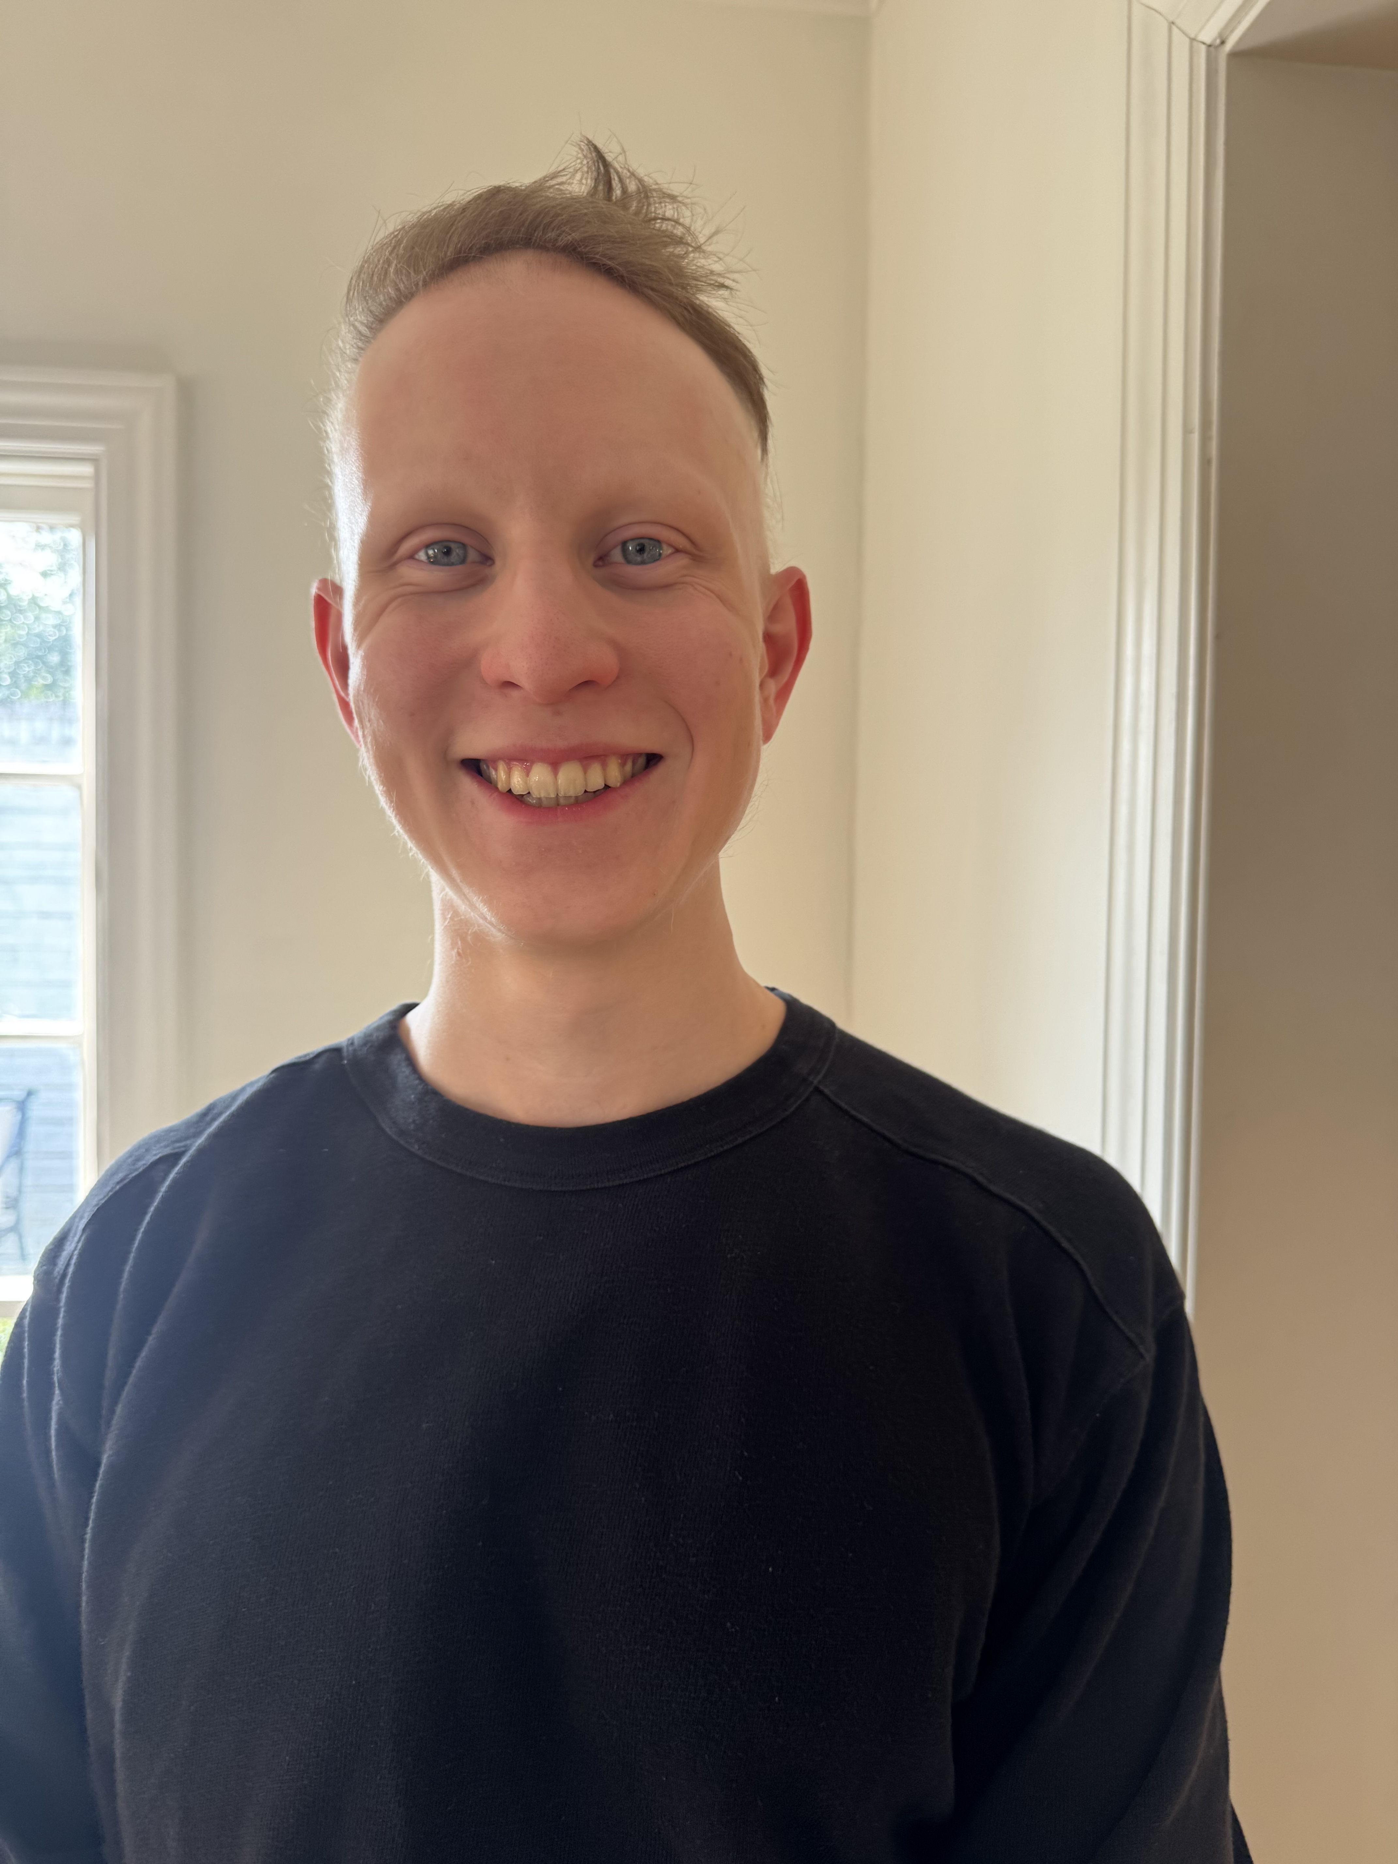
Brinkley Morse, Immunology & Microbiology, Baylor College of Medicine

Appointment: October 1, 2026 – September 30, 2027
Mentor: Katherine King, MD, PhD, Infectious Disease, Baylor College of Medicine
Co-Mentor: Katie Matatall, PhD, Infectious Disease, Baylor College of Medicine

Project Title: Tuning Interferon-Regulating Gene Expression in Hematopoietic Stem and Progenitor Cells to Induce Trained Immunity

Innate immune cells, such as neutrophils and macrophages, are the body's first responders against infection. Despite the dogma that these cells do not adapt to infectious conditions, numerous studies indicate that these cells gain functional efficiency after repeated infection, pointing toward innate immune cell memory. Furthermore, other studies suggest that innate immune memory is stored in the stem and progenitor cells of the bone marrow, but how this occurs is unknown.

The King lab recently discovered a subpopulation of blood stem cells (HSCs) that arises in response to infection. Innate immune cells produced by these infection-activated HSCs (IA-HSCs) display features of long-term memory, including a stronger ability to kill invading pathogens. Many studies suggest that this type of long-term memory occurs due to changes in DNA that do not affect the DNA sequence itself, also known as epigenetic changes. Given that IA-HSC progeny can “remember” prior infections, we hypothesize that IA-HSCs contain epigenetic changes that confer this memory. In AIM 1, we will study how loss of specific epigenetic modifiers affects an organism’s ability to develop long-term memory. In AIM 2, we will test whether making epigenetic changes to certain genes is sufficient to create memory in HSCs. Together, these experiments will establish causal links between specific epigenetic modifications and memory in innate immune cells. With these data, we can learn to control innate immune memory, which could help us combat autoimmune diseases and cancer as well as develop more effective vaccines.

